EXPERIMENT 4
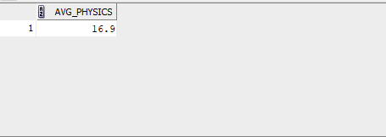
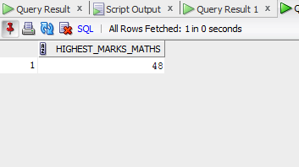
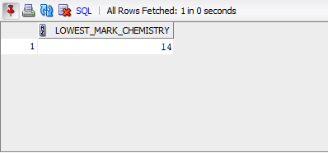
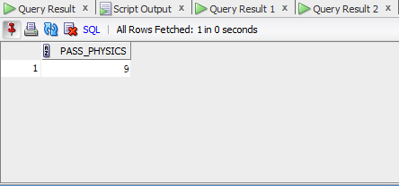
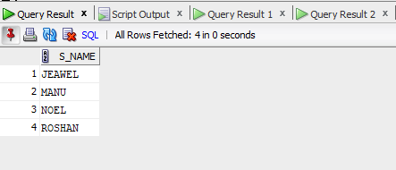
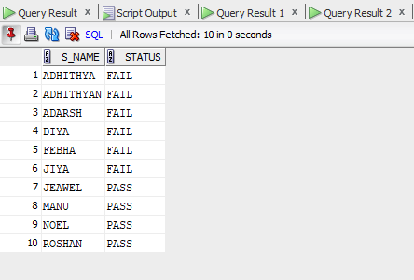
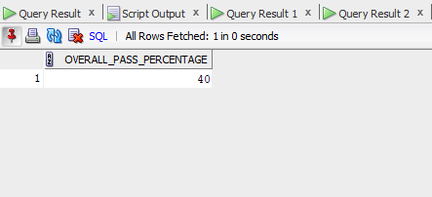
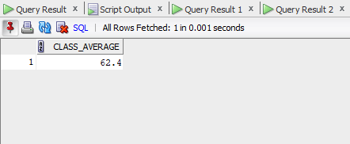
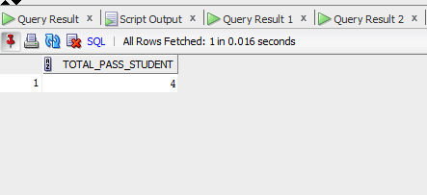

SOLUTION:
create table student_exp4( s_id int primary key,s_name varchar(30),physics int,
chemistery int,mathematics int);
insert into student_exp4 values(1,'ADHITHYA',15,18,20);
insert into student_exp4 values(2,'ADHITHYAN',16,14,19);
insert into student_exp4 values(3,'ADARSH',17,14,20);
insert into student_exp4 values(4,'DIYA',11,19,15);
insert into student_exp4 values(5,'FEBHA',15,15,15);
insert into student_exp4 values(6,'JIYA',21,22,24);
insert into student_exp4 values(7,'JEAWEL',24,24,48);
insert into student_exp4 values(8,'MANU',19,23,31);
insert into student_exp4 values(9,'NOEL',12,23,39);
insert into student_exp4 values(10,'ROSHAN',19,18,34);

SELECT * FROM student_exp4;
desc student_exp4;

SELECT AVG(physics) AS avg_physics FROM student_exp4;
SELECT MAX(mathematics) AS highest_marks_maths FROM student_exp4;
SELECT MIN(chemistery) AS lowest_mark_chemistry FROM student_exp4;
SELECT COUNT(*) AS pass_physics FROM student_exp4 WHERE physics>=12;
SELECT s_name FROM student_exp4 WHERE physics >= 12 AND chemistery >=12 AND mathematics>=25;
ALTER TABLE student_exp4 ADD STATUS VARCHAR(20);
UPDATE student_exp4 SET STATUS='PASS' WHERE physics >= 12 AND chemistery >=12 AND mathematics>=25;
UPDATE student_exp4 SET STATUS='FAIL' WHERE physics< 12 OR chemistery <12 OR mathematics<25;
SELECT s_name , STATUS FROM student_exp4;

SELECT COUNT(CASE WHEN mathematics >= 25 AND physics >= 12 AND chemistery >=12
THEN 1 END) * 100.0 / COUNT(*) AS overall_pass_percentage FROM student_exp4;

SELECT AVG(mathematics+physics+chemistery) AS class_average FROM student_exp4;

SELECT COUNT(*) AS total_pass_student FROM student_exp4 WHERE physics >= 12
AND chemistery >=12 AND mathematics>=25;

